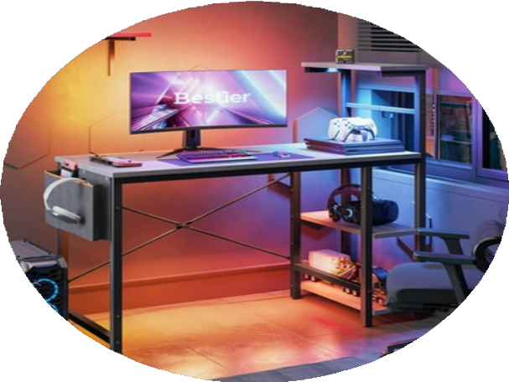

**Understanding**

**Computer**

**Systems**

 by Yasiru Prabodha CL/OTHMFL3/11/90

01

# **Introduction**

Welcome to our comprehensive Information Booklet designed to equip all employees with essential knowledge about computer systems, hardware, software, ethics, and legal regulations governing the realm of computing. In today's digital age, understanding the fundamentals of computer systems is indispensable. Firstly, we will delve into the functions of a computer system, elucidating its pivotal role in processing, storing, and manipulating data to fulfill diverse tasks efficiently. From basic operations to complex computations, grasp the core functionalities that empower our daily operations and productivity.

Next, we embark on an exploration of computer hardware, unveiling its myriad types, purposes, and distinguishing characteristics. Whether it's the central processing unit (CPU), memory modules, storage devices, or input/output peripherals, each component plays a crucial role in shaping the performance and capabilities of our computing infrastructure. By discerning the diverse hardware options and their functionalities, you'll gain insights into optimizing resources and selecting the most suitable equipment to meet our organizational needs. Let's embark on this enlightening journey to unlock the mysteries of computer technology and harness its transformative potential.

02

# **Acknowledgement**

We would like to express our sincere gratitude to Ms. Thilini, our wonderful computing professor, whose knowledge, direction, and assistance were crucial in the production of this information booklet. Her commitment to equipping us with computer knowledge and abilities has been crucial in forming the content and guaranteeing its relevance and accuracy.

We also acknowledge the contributions of all employees who provided insights, feedback, and suggestions during the development of this booklet. Your input has enriched the content and enhanced its effectiveness in fulfilling its purpose of educating and informing our workforce about the fundamentals of computer systems, hardware, software, ethical considerations, and legal obligations.

As a team, we work to instill a culture of comprehension, accountability, and compliance throughout our company, making sure that each person has the skills and understanding required to conduct themselves honorably and professionally in the digital sphere.

Thank you all for your unwavering support and commitment to continuous learning and improvement.

Sincerely,

Yasiru Prabodha

Company Trainer

|  |  |  |
| --- | --- | --- |
| **Table of**  **contents** |  | 03 |
| Functions Of A Computer | 04 |  |
| System |  |  |
| Computer Hardware | 05 |  |
| Different Types Of Software | 07 |  |
| Exploring Software Variety and | 09 |  |
| Their Purposes |  |  |
| Ethical Issues in Computing | 11 |  |
| Laws and Regulations Governing | 13 |  |
| Computing |  |  |
| Legal Action Against Unethical | 15 |  |
| and Illegal Computer Use |  |  |
| Reference | 17 |  |

## 04

Functions Of A Computer   System

**Input:** This function involves receiving data or instructions into the computer system. Input devices like keyboards, mice, touchscreens, scanners, and microphones are used to provide data and instructions to the computer.

**Processing:** Once data and instructions are received, the central processing unit (CPU) processes them. Processing involves performing calculations, executing instructions, and manipulating data according to the instructions provided. The CPU is the brain of the computer responsible for executing programs and managing data.

**Output:** After processing, the results are presented to the user in a meaningful form. Output devices like monitors, printers, speakers, and projectors display or produce the processed data and information in human-readable formats.

**Storage:** Data and instructions need to be stored for later use. Storage devices like hard disk drives (HDDs), solid-state drives (SSDs), USB flash drives, and optical disks are used to store data permanently or temporarily. Memory (RAM) is also considered a form of storage but is volatile, meaning it loses its contents when the power is turned off.

## 05

Computer Hardware

Physical component of the computer system that you can touch and see.

### Central Processing Unit (CPU)

**Purpose:** The CPU is the brain of the computer, responsible for executing instructions and performing calculations.

 **Characteristics:** Speed (measured in GHz), number of cores, cache size, architecture (e.g., x86, ARM).

### Motherboard

 **Purpose:** The motherboard serves as the main circuit board of the computer, providing connections for other components to communicate with each other.

 **Characteristics:** Form factor (e.g., ATX, microATX), chipset, expansion slots (e.g., PCIe), connectors (e.g., USB, SATA), onboard features (e.g., audio, networking).

### Graphics Processing Unit (GPU)

 **Purpose:** GPUs are specialized processors designed to handle graphics rendering tasks efficiently, essential for gaming, visual design, and certain scientific applications.

 **Characteristics:** Number of cores/stream processors, clock speed, memory (e.g., VRAM), compute capability.

### Random Access Memory (RAM)

**Purpose:** RAM temporarily stores data and program instructions that the CPU needs to access quickly.

 **Characteristics:** Capacity (measured in gigabytes), speed (measured in MHz or GHz), type (e.g., DDR4, DDR5).

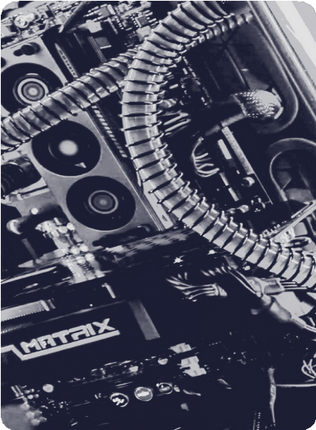

## 06

### Storage Devices - Hard Disk Drive (HDD)

**Purpose:** HDDs provide long- term storage for data and programs, retaining information even when the computer is powered off.

**Characteristics:** Capacity (measured in terabytes), rotational speed (measured in RPM), form factor (e.g., 3.5-inch, 2.5-inch).

### Storage Devices - Hard Disk Drive (HDD)

**Purpose:** SSDs offer faster read/write speeds compared to HDDs due to their lack of moving parts, making them suitable for both operating system and data storage.

**Characteristics:** Capacity, read/write speeds (measured in MB/s or GB/s), form factor (e.g., M.2, SATA).

### Networking Components

 **Purpose:** These include network interface cards (NICs), routers, switches, and modems for connecting computers to networks and the internet.

 **Characteristics:** include data transfer speeds (e.g., Ethernet speeds), wireless standards (e.g., Wi-Fi 6), and connectivity options.

### Storage Devices - External Storage Devices (USB flash drives, external hard drives)

 **Purpose:** External storage devices allow for portable storage and data transfer between computers.

 **Characteristics:** Capacity, portability, interface (e.g., USB- A, USB-C, Thunderbolt).

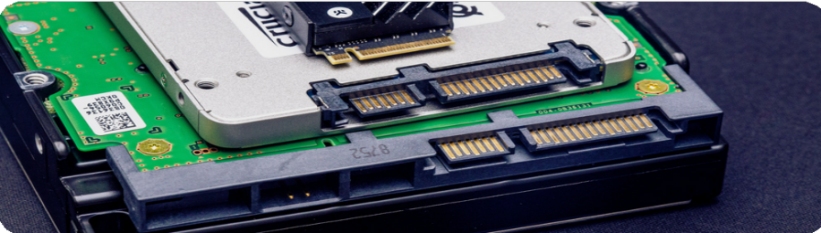

## 07

Different Types Of Software

### System Software

This type of software is designed to provide a platform for other software to run on. It includes operating systems like Windows, macOS, Linux, Unix, etc., as well as device drivers, firmware, and utility programs that manage computer hardware resources.

### Application Software

Application software is any software designed to perform a specific task or set of tasks for the user. This includes a wide range of programs such as word processors, spreadsheets, web browsers, email clients, media players, graphic design software, and so on.

### Programming Software

Programming software includes tools used by developers to create, debug, and maintain other software. This includes integrated development environments (IDEs), compilers, interpreters, debuggers, and text editors.

### Utilities

Utilities are software programs that perform specific tasks related to managing and maintaining computer systems. Examples include antivirus software, disk cleanup tools, backup software, and file compression utilities.

### Middleware

Middleware is software that connects different software components or applications and enables them to work together. It often facilitates communication and data exchange between different systems or software components.

## 08

### general purpose software

General-purpose software refers to programs and applications that are designed to be versatile and applicable to a wide range of tasks or purposes, rather than being specialized for a specific function or industry.

### Tailor made software

Tailor-made software, also known as custom software, is specially designed and developed to meet the specific needs and requirements of a particular individual, organization, or business.

### Entertainment Software

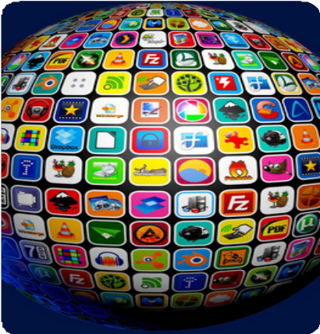Entertainment software encompasses a wide range of programs designed for leisure and entertainment purposes. This includes video games, multimedia applications, virtual reality experiences, and streaming media services.

### Driver software

Driver software facilitates communication between a computer's operating system and hardware devices, enabling them to work together seamlessly by translating instructions from the OS into commands that the hardware can understand.

### specialist software

Specialist software refers to programs designed for specific industries or niche applications, tailored to meet unique requirements. Examples include medical imaging software for healthcare or CAD software for engineering.

### Open Source Software

Open source software is software whose source code is freely available to the public, allowing users to study, modify, and distribute the software. Examples include the Linux operating system, the Apache web server, and the Mozilla Firefox web browser.

## 09

Exploring Software Variety   and Their Purposes

### Operating Systems (OS)

**Purpose:** Manage hardware resources and provide a user interface for interacting with the computer.

 **Examples:** Windows, macOS, Linux, iOS, Android.

### Word Processing Software

 **Purpose:** Create, edit, format, and print documents.

 **Examples:** Microsoft Word, Google Docs, Apple Pages.

### Spreadsheet Software

 **Purpose:** Organize, analyze, and manipulate numerical data.

 **Examples:** Microsoft Excel, Google Sheets, Apple Numbers.

### Graphic Design Software

 **Purpose:** Create and manipulate visual content.

 **Examples:** Adobe Photoshop, Adobe Illustrator, CorelDRAW.

### Presentation Software

**Purpose:** Create slideshows for presenting information.

 **Examples:** Microsoft PowerPoint, Google Slides, Apple Keynote.

### Web Browsers

 **Purpose:** Access and navigate the World Wide Web.

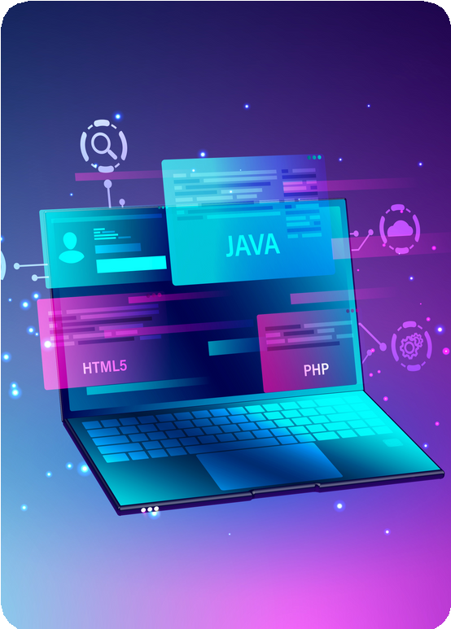 **Examples:** Google Chrome, Mozilla Firefox, Safari, Microsoft Edge.

## 10

### Video Editing Software

**Purpose:** Edit and manipulate video footage.

**Examples:** Adobe Premiere Pro, Final Cut Pro, DaVinci Resolve.

### Accounting Software

**Purpose:** Manage financial transactions and generate reports.

 **Examples:** QuickBooks, Xero, FreshBooks.

### Database Management Software (DBMS)

 **Purpose:** Store, manage, and retrieve data efficiently.

 **Examples:** MySQL, Microsoft SQL Server, Oracle Database.

### Integrated Development Environments (IDEs)

 **Purpose:** Provide comprehensive tools for software development.

 **Examples:** Visual Studio, IntelliJ IDEA, Eclipse.

### Customer Relationship Management (CRM) Software

 **Purpose:** Manage interactions with current and potential customers.

 **Examples:** Salesforce, HubSpot CRM, Zoho CRM.

### Audio Editing Software

**Purpose:** Edit and manipulate audio recordings.

**Examples:** Adobe Audition, Audacity, GarageBand.

### Antivirus Software

**Purpose:** Protect against viruses, malware, and other online threats.

 **Examples:** Norton Antivirus, McAfee Antivirus, Avast.

### Virtualization Software

 **Purpose:** Create and manage virtual machines.

 **Examples:** VMware, VirtualBox, Hyper-V.

### Project Management Software

 **Purpose:** Plan, organize, and track projects and tasks.

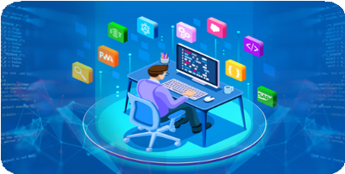 **Examples:** Trello, Asana, Microsoft Project.

## 11

Ethical Issues in Computing

### Privacy

The collection, storage, and use of personal data by companies and governments raise significant privacy concerns. Issues include unauthorized surveillance, data breaches, and the lack of transparency in data handling practices.

### Algorithmic Bias

Algorithms can perpetuate or even exacerbate biases present in society, leading to unfair treatment or discrimination against certain groups. This can occur in areas such as hiring, lending, and criminal justice.

### Intellectual Property

The unauthorized use or distribution of copyrighted material, software piracy, and patent infringement are ethical issues in computing. Balancing the rights of creators with the public interest in accessing information is a complex ethical dilemma.

### Security

Cybersecurity is a major concern due to the potential for data breaches, hacking, and cyberattacks. Ethical considerations include the responsible disclosure of vulnerabilities, the development of secure systems, and the protection of user data.

### Accessibility

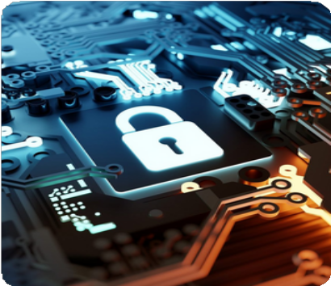Ensuring that technology is accessible to all individuals, including those with disabilities, is an ethical imperative. Failure to consider accessibility can lead to exclusion and discrimination.

## 12

### Artificial Intelligence and Automation

As AI systems become more prevalent, concerns arise about their impact on employment, decision-making processes, and societal values. Ethical

considerations include accountability for AI decisions, transparency in AI algorithms, and the potential for job displacement.

### Surveillance

The widespread use of surveillance technologies, such as facial recognition and location tracking, raises concerns about privacy, civil liberties, and government overreach.



### Digital Divide

Disparities in access to technology and digital resources contribute to inequality. Bridging the digital divide involves addressing issues such as affordability, infrastructure, and digital literacy.

### Environmental Impact

The production, use, and disposal of computing devices contribute to environmental degradation. Ethical considerations include sustainable design practices, responsible disposal of electronic waste, and reducing energy consumption.

### Ethical AI Development

Ensuring that AI systems are developed and deployed in an ethical manner requires consideration of factors such as fairness, transparency, accountability, and the potential for unintended consequences.

### Automation and Job Displacement

Automation refers to the use of technology to perform tasks previously done by humans. Job displacement occurs when automation replaces human workers, leading to unemployment. This shift challenges labor markets, necessitating retraining and adaptation to new employment opportunities.

## 13

Laws and Regulations  Governing Computing

### Data Protection and Privacy Laws

These laws govern how personal data is collected, processed, stored, and shared. Examples include the General Data Protection Regulation (GDPR) in the European Union and the California Consumer Privacy Act (CCPA) in the United States.

### Cybersecurity Laws

These laws aim to protect computer systems and networks from cyber threats. They may include requirements for organizations to implement security measures and report security breaches.

### Telecommunications Regulations

These regulations govern the provision of telecommunications services, including internet service providers (ISPs), mobile networks, and other communication technologies.

### Digital Accessibility Laws

These laws require websites, software, and digital services to be accessible to people with disabilities.

### Intellectual Property Laws

These laws protect intellectual property rights, including patents, copyrights, and trademarks. They govern issues such as software licensing, copyright infringement, and patent disputes.

### E-Commerce Laws

These laws regulate online transactions, electronic contracts, and consumer protection in the digital marketplace.

### Export Controls and Sanctions

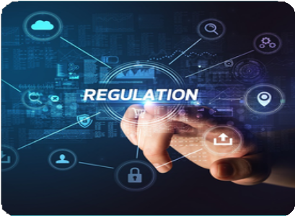These regulations restrict the export of certain technologies and software to certain countries or entities for national security or foreign policy reasons.

## 14

### Digital Accessibility Laws

These laws require websites, software, and digital services to be accessible to people with disabilities.

### Cloud Computing Regulations

These regulations address the legal and regulatory issues associated with cloud computing services, including data sovereignty, data protection, and liability.

### Competition Laws

These laws regulate anticompetitive behavior in the technology sector, including monopolies, mergers, and unfair competition practices.

### Surveillance and Interception Laws

These laws regulate government surveillance activities and the interception of communications.

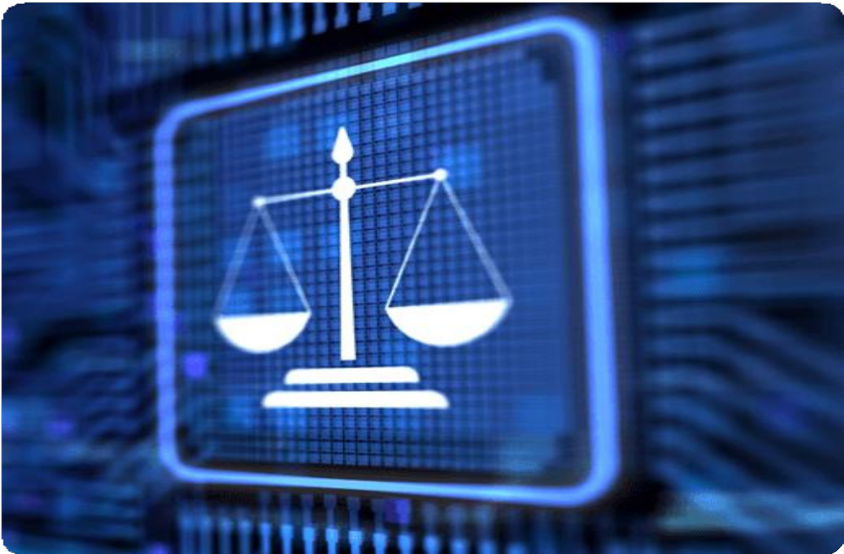

## 15

Legal Action Against Unethical and Illegal Computer Use

### Cybercrime

Many countries have specific laws targeting cybercrimes, such as hacking, identity theft, and cyberstalking. For instance, the United States has the Computer Fraud and Abuse Act (CFAA), which prohibits unauthorized access to computer systems.

### Intellectual Property Infringement

Copyright and trademark laws are enforced to combat online piracy, counterfeiting, and other forms of intellectual property infringement, such as illegally downloading movies, music, or software.

### Online Fraud

Laws exist to prosecute individuals who engage in online fraud schemes, including phishing scams, online auction fraud, and fraudulent investment schemes conducted through the internet.

### Child Exploitation

Laws like the Protect Our Children Act and the Child Online Protection Act (COPA) target individuals who use computers to produce, distribute, or access child pornography and engage in online grooming of minors.

### Data Breaches

Laws like the European Union's General Data Protection Regulation (GDPR) and the California Consumer Privacy Act (CCPA) impose penalties on individuals and organizations that fail to protect personal data from unauthorized access or disclosure.

### Online Harassment and Cyberbullying

Laws in various jurisdictions address online harassment and cyberbullying, including sending threatening or harassing messages via email, social media, or other digital platforms.

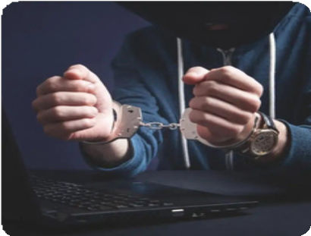

## 16

### Cyberterrorism and State- Sponsored Cyberattacks

Governments around the world have enacted laws to address cyberterrorism and state- sponsored cyberattacks, which involve using computers to disrupt critical infrastructure, steal sensitive information, or spread propaganda.

### Online Extortion and Ransomware

Laws are enforced against individuals who engage in online extortion and ransomware attacks, where hackers encrypt data or threaten to release sensitive information unless a ransom is paid.

### Distributed Denial of Service (DDoS) Attacks

Laws in various countries prohibit individuals from launching DDoS attacks, which involve overwhelming a computer system or network with a flood of traffic to disrupt its normal functioning.

### Unauthorized Access to Government Systems

Laws prohibit unauthorized access to government computer systems and networks, as well as the theft or dissemination of classified or sensitive information.

### Unauthorized Access to Financial Systems

Laws address unauthorized access to financial systems and networks, including instances of hacking into bank accounts, credit card fraud, and other forms of financial cybercrime.

### Unauthorized Access to Medical Records

With the increasing digitization of healthcare records, laws such as the Health Insurance Portability and Accountability Act (HIPAA) in the United States enforce strict regulations to protect the privacy and security of patients' medical information.

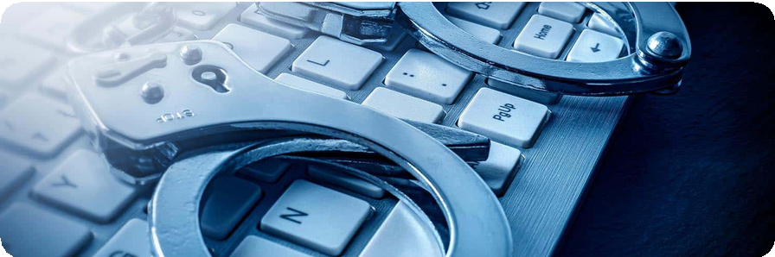

## 17

# **References**

Anon., 2020. *What are the criminal penalties for hacking? - findlaw.* [Online]   
Available at: https://www.findlaw.com/legalblogs/criminal-defense/what-are-the-criminal-penalties-for-hacking/  
[Accessed 08 april 2024].

Anon., 2024. *7 Legal and Ethical Perspectives on Cyberattack | Technology, Policy, Law, and Ethics Regarding U.S. Acquisition and Use of Cyberattack Capabilities | The National Academies Press.* [Online]   
Available at: https://nap.nationalacademies.org/read/12651/chapter/12  
[Accessed 09 April 2024].

Anon., 2024. *Crucial.* [Online]   
Available at: https://www.crucial.com/articles/pc-builders/what-is-computer-hardware  
[Accessed 10 April 2024].

Anon., 2024. *Encyclopædia Britannica.* [Online]   
Available at: https://www.britannica.com/technology/operating-system  
[Accessed 11 april 2024].

Anon., 2024. *Encyclopædia Britannica.* [Online]   
Available at: https://www.britannica.com/technology/operating-system  
[Accessed 11 april 2024].

Anon., 2024. *U.S. Chamber of Commerce.* [Online]   
Available at: https://www.uschamber.com/security/cybersecurity/international-cyber-law-project  
[Accessed 12 April 2024].

Anon., 2024. *ZDNET.* [Online]   
Available at: https://www.zdnet.com/education/computers-tech/ethical-dilemmas-computer-science  
[Accessed 09 april 2024].

Council of Europe, 2023. *Cybercrime.* [Online]   
Available at: https://www.coe.int/en/web/cybercrime/-/the-global-state-of-cybercrime- legislation-as-at-january-2023-  
[Accessed 10 April 2024].

Thadious, M. & Hasa, 2024. *ArtOfTesting.* [Online]   
Available at: https://artoftesting.com/functions-of-computer  
[Accessed 12 april 2024].

18

**THANK YOU!**

**More Information**

[**www.yasiru.xyz/f/othmcomputingsubmit**](https://www.yasiru.xyz/r/othmcomputepp)

(Presentation video)

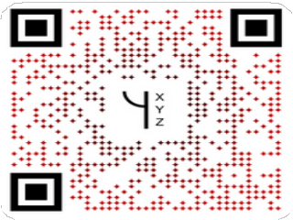

**End !**